**1. What is our independent variable? What is our dependent variable?**

***Independent Variable***

The two conditions: a congruent words condition and an incongruent words condition is the independent variable.

***Dependent Variable***

The recorded response times of the participants are the dependent variables.

**2. What is an appropriate set of hypotheses for this task? What kind of statistical test do you expect to perform? Justify your choices.**

***Null Hypothesis***

**H0**: The mean time of response for incongruent tasks will be lower than congruent tasks or that there would be no significant difference in the response time between the two tests.

**H0**: 

***Alternative Hypothesis***

**HA:** Mean time of response will be longer for incongruent tasks than congruent tasks.

**HA:** 

where,

= The population mean response times for congruent tasks

= The population mean response times for incongruent tasks

The project details don’t mention whether we should investigate the effects of incongruent tasks increasing the response times thereby making this project suitable for a one tailed dependent samples t-test. We are choosing a t-test since we do not know any population parameters, so a z-score approach will be inappropriate. We are choosing a dependent samples test because the same group of people undergo both the conditions and are examined for each test which is how the ‘repeated measures’ statistical tests are defined. We are also choosing to do a one tailed test under the intuitive assumption that the incongruent tasks will not improve the response times.

**3. Report some descriptive statistics regarding this dataset. Include at least one measure of central tendency and at least one measure of variability.**

|  |  |  |  |
| --- | --- | --- | --- |
| Statistic | Congruent Task | Incongruent Task | Difference of Congruent & Incongruent |
| Number(n) | 24 | 24 | 24 |
| Mean ($\overline{x}$) | 14.05 | 22.015 | -7.9648 |
| Variance | 12.667 | 23.01 | 23.6666 |
| Standard Deviation | 3.56 | 4.80 | 4.8648 |
| Sum of Squares | 316.682 | 553.164 | 544.330 |
| Standard Error | 0.73 | 0.96 | 0.99 |

**4. Provide one or two visualizations that show the distribution of the sample data. Write one or two sentences noting what you observe about the plot or plots.**

We can observe that the data is roughly normally distributed with a slight left skew. Plotted below is a clustered column bar graph of response times for congruent and incongruent tasks. We can clearly see that incongruent tasks take more time for the participants to complete than congruent tasks.

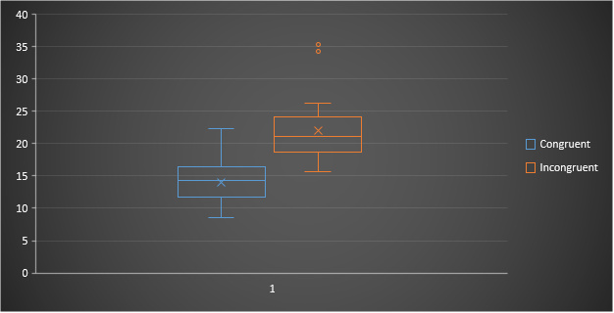

This boxplot shows the median for both the congruent and incongruent tasks and indicates the evident outliers present in both. This boxplot also affirms the notion that incongruent tasks take more time than congruent tasks.

**5. Now, perform the statistical test and report your results. What is your confidence level and your critical statistic value? Do you reject the null hypothesis or fail to reject it? Come to a conclusion in terms of the experiment task. Did the results match up with your expectations?**

= 0.01

Degrees of Freedom = 23

tcrit = -2.50

tstat = -8.02

p-value < 0.0001

The calculated t-statistic for the difference in the response times of congruent and incongruent times is -8.02. Since it lies in the critical region, we *reject the null hypothesis.*  The results may be deemed as statistically significant. We may conclude from this data that people recognize words whose meaning and colour match faster than when both the meaning and colour do not match. The results managed to satisfy my expectations.

**6. Optional: What do you think is responsible for the effects observed? Can you think of an alternative or similar task that would result in a similar effect? Some research about the problem will be helpful for thinking about these two questions!**

One of the possible reasons for this effect might be because there is a lag in the brain’s ability to recognize the colour of the word since it reads the word faster than it recognizes the colour of the word. If there is a conflict between identifying words and colours, the word information arrives at the decision-making stage before the colour information. A similar effect might be the emotional Stroop effect. This test is used as an information-processing approach to assessing emotions. Related to the standard Stroop effect, the emotional Stroop test works by examining the response time of the participant to name colors of negative emotional words. For example, depressed participants will be slower to say the color of depressing words rather than non-depressing words.

**References: -1)** [Wikipedia-Stroop Effect(Emotional)](https://en.wikipedia.org/wiki/Stroop_effect#Emotional)

**2)** [Psychology Tests](http://www.psychology.emory.edu/clinical/bliwise/Tutorials/TOM/meanstests/assump.htm)